E-COMMERCE BRAZILIAN STORE ANALYSIS IN THE PERIOD OF 2016 - 2018

1.Create the different metrics like Sales, customer acquisitions and total no. of orders for each Year across the different states they serve.

Query 1:-

**It Shows the Total sales as per order id.**

select orders.customer_id, o.order_id,sum(o.payment_value) as Sales from orders join order_payments o on

o.order_id = orders.order_id group by orders.customer_id,o.order_id;

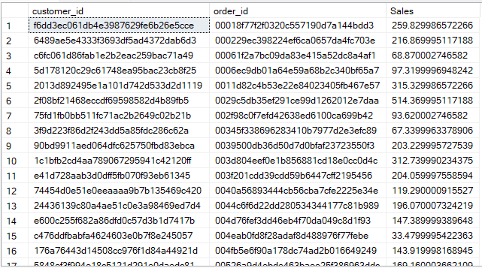

**It shows the customer state with their state zip code as per customer id.**

select customer_id ,customer_zip_code_prefix,customer_state from customers ;

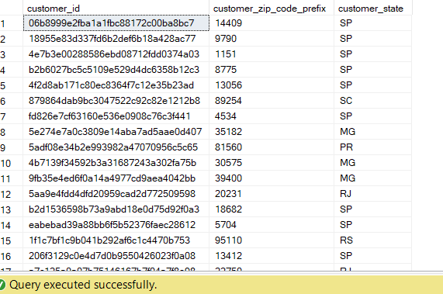

**It Shows the Total orders of customers as per state.**

select customers.customer_id,orders.order_delivered_customer_date,customers.customer_state,

count(orders.order_id) as Total_no_of_orders from orders

join customers on customers.customer_id=orders.customer_id

group by customers.customer_id,orders.order_delivered_customer_date,

customers.customer_state ;

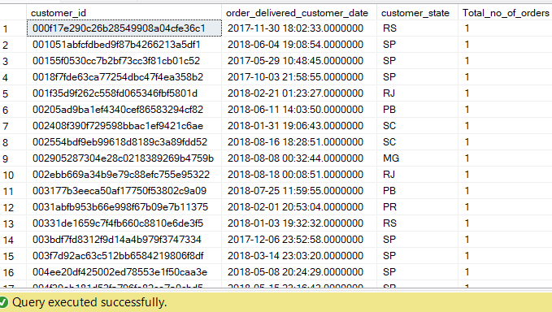

**This query represents the total no. of orders in each State where all the order is delivered(date).**

2. Using the above metrics, identify the top 2 States which show

i. The declining trend over the years

ii. Increasing trend over the years

(Choose yourself the best-suited metrics amongst all 3 in point (1) to carry out the analysis)

Query 2:-

**It Shows the Top 2 states by declining the trend over the years**

1. select top 2 c.customer_state,year(orders.order_purchase_timestamp) as purchase_order_in_year,sum(o.payment_value) as Sales_as_per_state from orders

join customers c on c.customer_id = orders.customer_id

join order_payments o on o.order_id = orders.order_id group by

orders.customer_id,c.customer_state,orders.order_purchase_timestamp order by purchase_order_in_year desc;

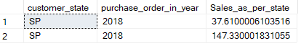

**It Shows the Top 2 state by Increasing the trend over the years.**

2. select top 2 orders.customer_id, c.customer_state,year(orders.order_purchase_timestamp) as purchase_order_in_year,sum(o.payment_value) as Sales_as_per_state from orders

join customers c on c.customer_id = orders.customer_id

join order_payments o on o.order_id = orders.order_id group by

orders.customer_id,c.customer_state,orders.order_purchase_timestamp order by

purchase_order_in_year;

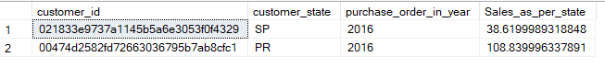

**Conclusion:-This query represents the top 2 last order purchase state and sales in 2018 and top 2 first order purchase state and sales in 2016**.

1. For the States identified above, do the Root Cause Analysis for their performance across a variety of metrics.

You can utilize the following metrics and explore a few yourself as well by analyzing the data.

Category level Sales and orders placed, post-order reviews, Seller performance in terms of deliveries, product-level sales & orders placed,

% of orders delivered earlier than the expected date, % of orders delivered later than the expected date, etc.

Query 3:-

**It Represents the number of orders is delivered by the seller as per the order purchase.**

select s.seller_id,sum(o.price) as Single_category_price,orders.order_purchase_timestamp as Order_purchase,

count(p.product_category_name) as Category_level_sales,

count(orders.order_status) as order_delivered,count(p.product_id) as product_sales from order_items o join products p on

p.product_id = o.product_id join sellers s on o.seller_id = s.seller_id

join orders on o.order_id = orders.order_id group by s.seller_id,

orders.order_purchase_timestamp;

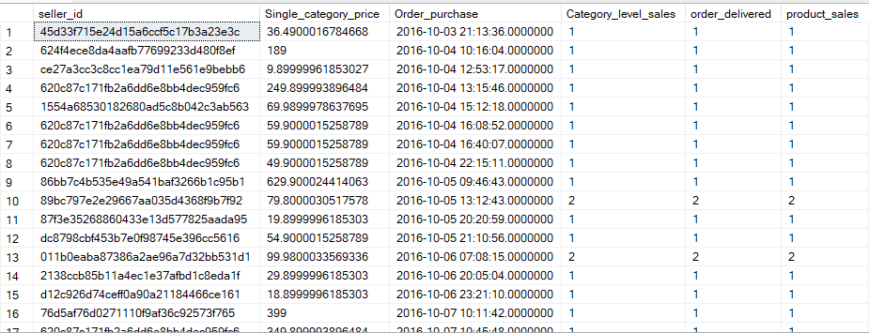

**It Shows the % of the orders is delivered before the actual Date and Time.**

select (count(case when order_delivered_customer_date > order_estimated_delivery_date then 1 end) * 100/

count(*)) as percentage_early from orders;



**It Shows the % of the orders is delivered after the actual Date and Time.**

select (count(case when order_delivered_customer_date < order_estimated_delivery_date then 1 end) * 100/

count(*)) as percentage_later from orders;



1. Do the above analysis for the top 2 cities which are causing the trend for each of the states identified in point (2)

Query 4:-

**It represents the Top 2 cities which are declining the trend over the years.**

select top 2 c.customer_city,year(orders.order_purchase_timestamp) as purchase_order_in_year,sum(o.payment_value) as Sales_as_per_city from orders

join customers c on c.customer_id = orders.customer_id

join order_payments o on o.order_id = orders.order_id group by

orders.customer_id,c.customer_city,orders.order_purchase_timestamp order by purchase_order_in_year desc;

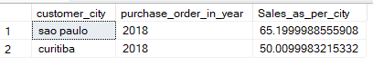

**It represents the Top 2 cities which are increasing the trend over the years.**

select top 2 c.customer_city,year(orders.order_purchase_timestamp) as purchase_order_in_year,sum(o.payment_value) as Sales_as_per_city from orders

join customers c on c.customer_id = orders.customer_id

join order_payments o on o.order_id = orders.order_id group by

orders.customer_id,c.customer_city,orders.order_purchase_timestamp order by purchase_order_in_year asc;

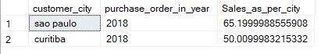

1. After doing the Root cause analysis, help the client by suggesting ways to improve the performance of the States and the cities

Query 5:-

* Improve the delivery rate and always delivered the product before the expected date by this customer always choose your shop and buy products as need .
* Provide your service fast and always reminder your customer about your shop .